**Program 1**

**Write a python program to test a given number is prime or not**

num = int(input("enter the number you want to test as prime or not : "))

if num > 1:

for i in range(2, int(num/2)+1):

if (num % i) == 0:

print(num, "is not a prime number")

break

else:

print(num, "is a prime number")

else:

print(num, "is not a prime number")

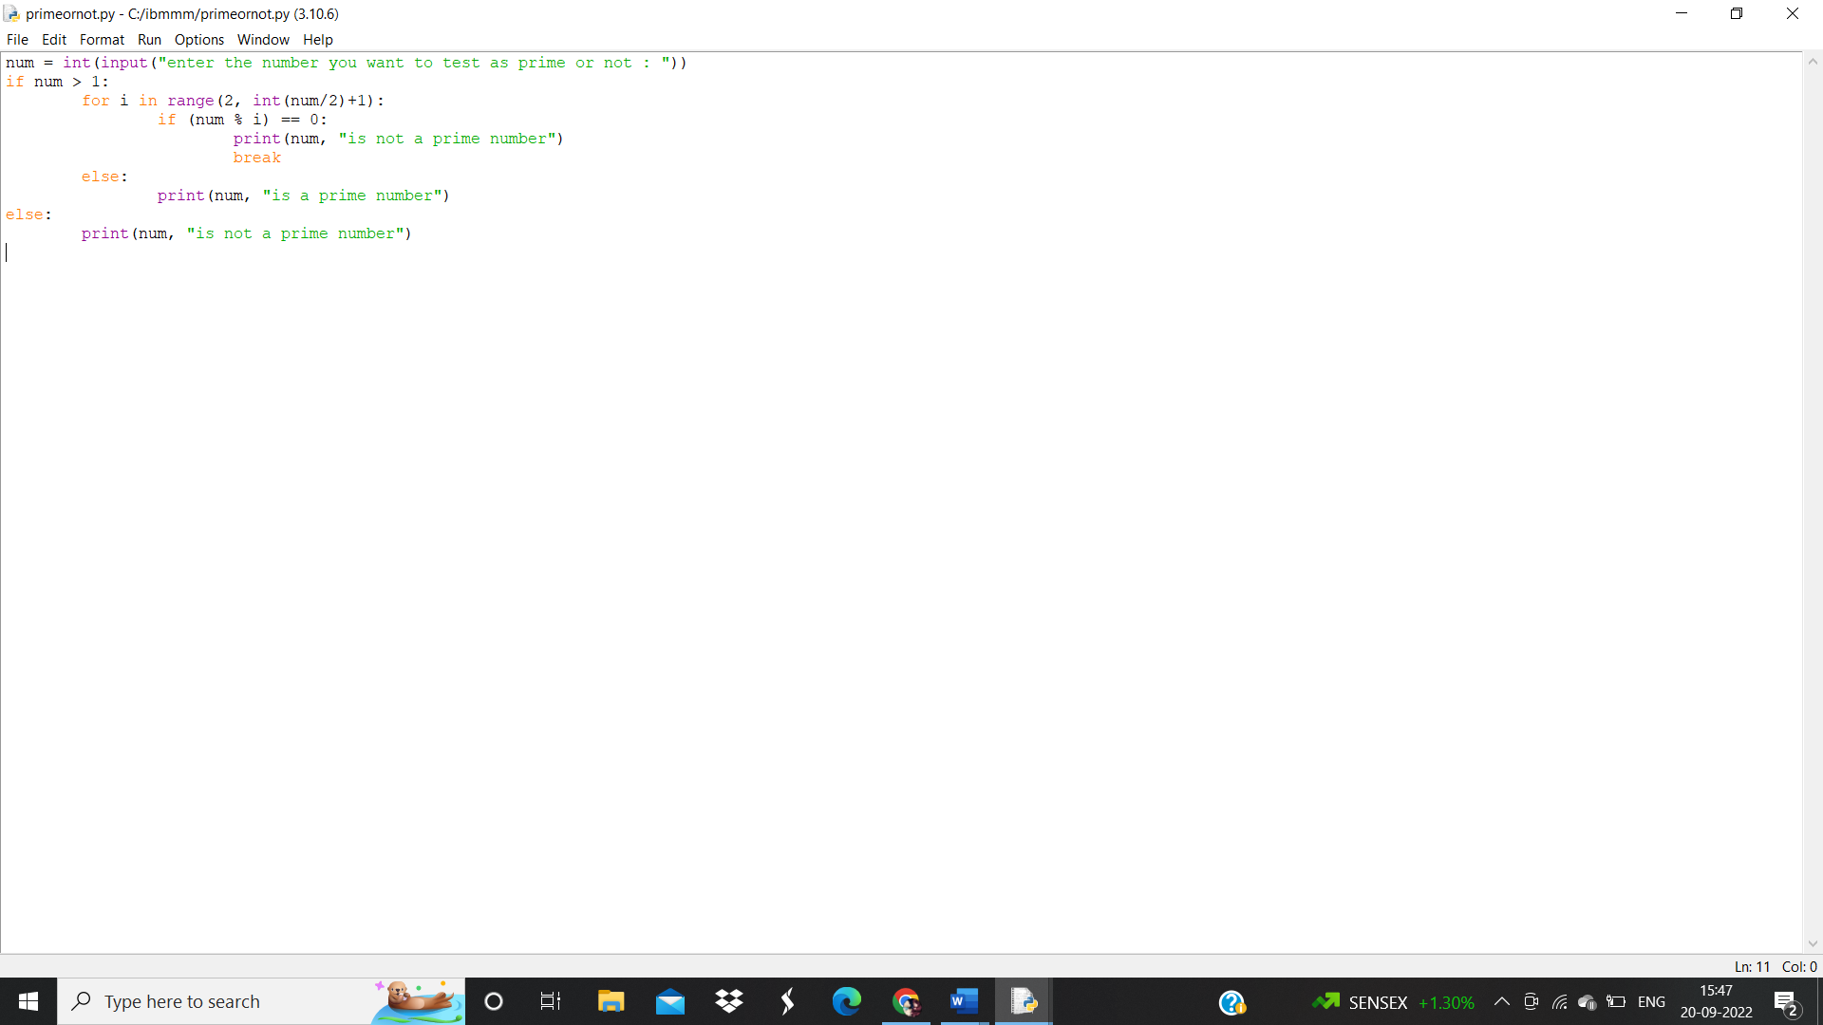

**Output:**

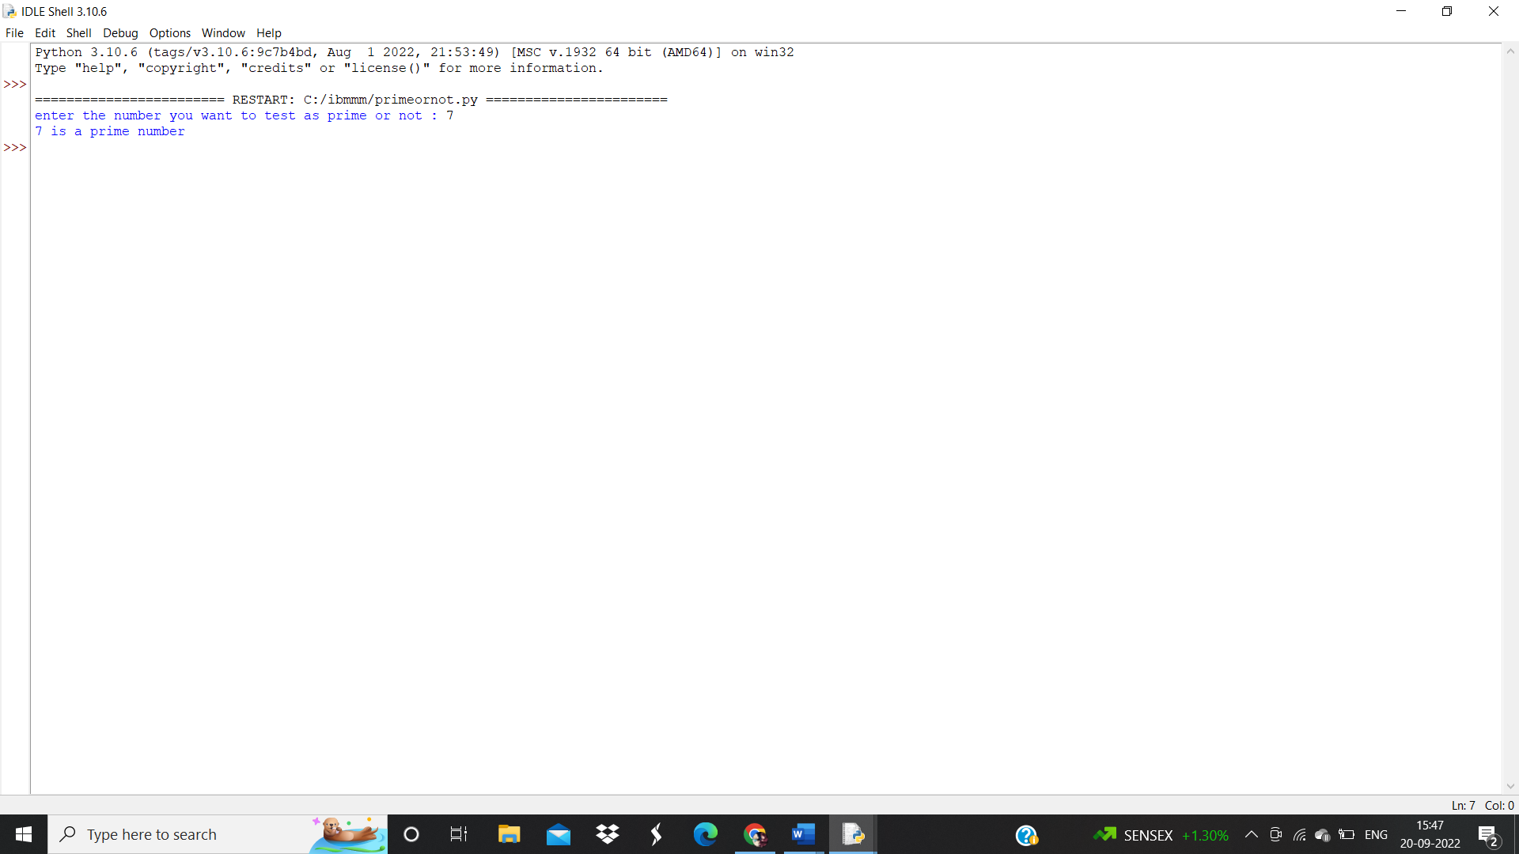

**Program 2:**

**write a program to generate odd numbers from m to n using while loop.**

minimum = int(input(" enter m minimum value:"))

maximum = int(input(" enter n maximum value: "))

X=1;

if (minimum < maximum):

while X in range(minimum,maximum + 1):

if( X % 2 != 0):

print("{0}".format(X))

X=X+1;

else:

print("Minimum value must be less than maximum value")

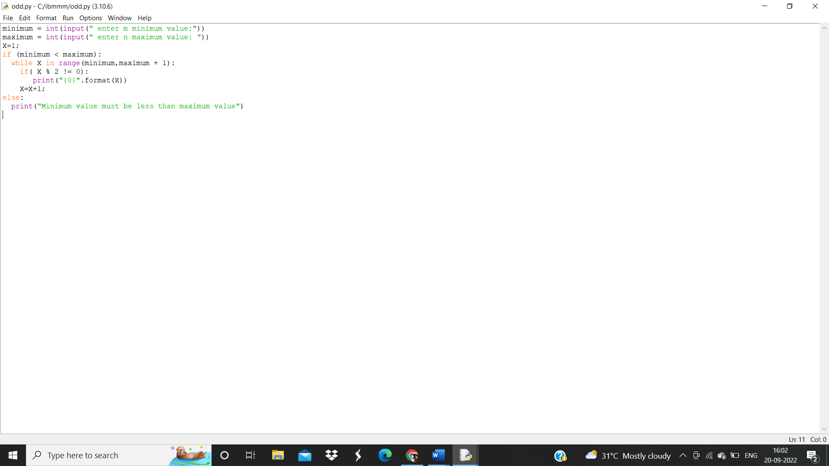

**Output:**

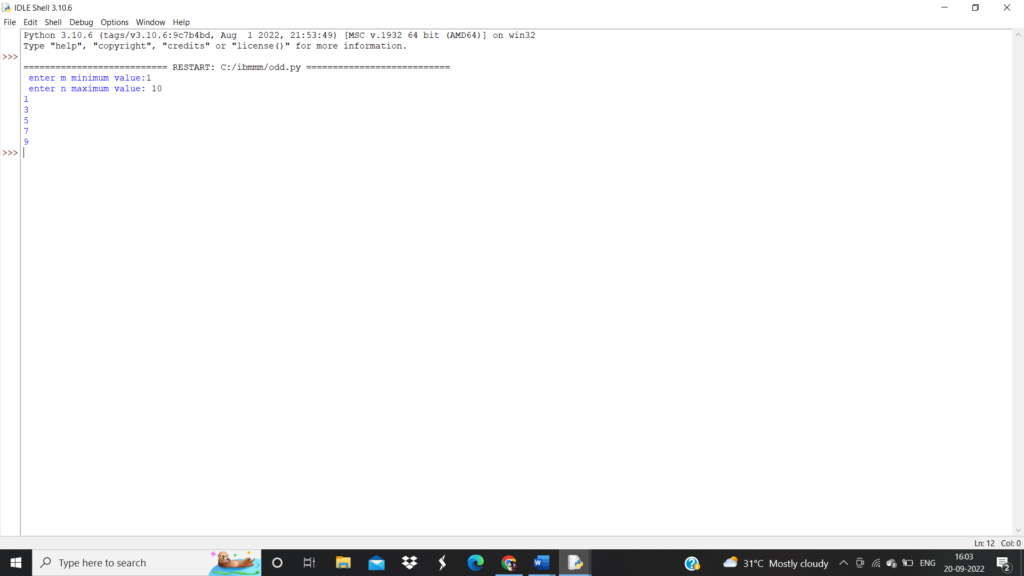

**Program 3:**

**Write a python program to display prime number series upto a given number**

upper_value = int(input ("Please, Enter the Upper Range Value: "))

number=1

print ("The Prime Numbers in the range are: ")

for number in range (number,upper_value + 1):

if number > 1:

for i in range (2, number):

if (number % i) == 0:

break

else:

print (number)

**output:**

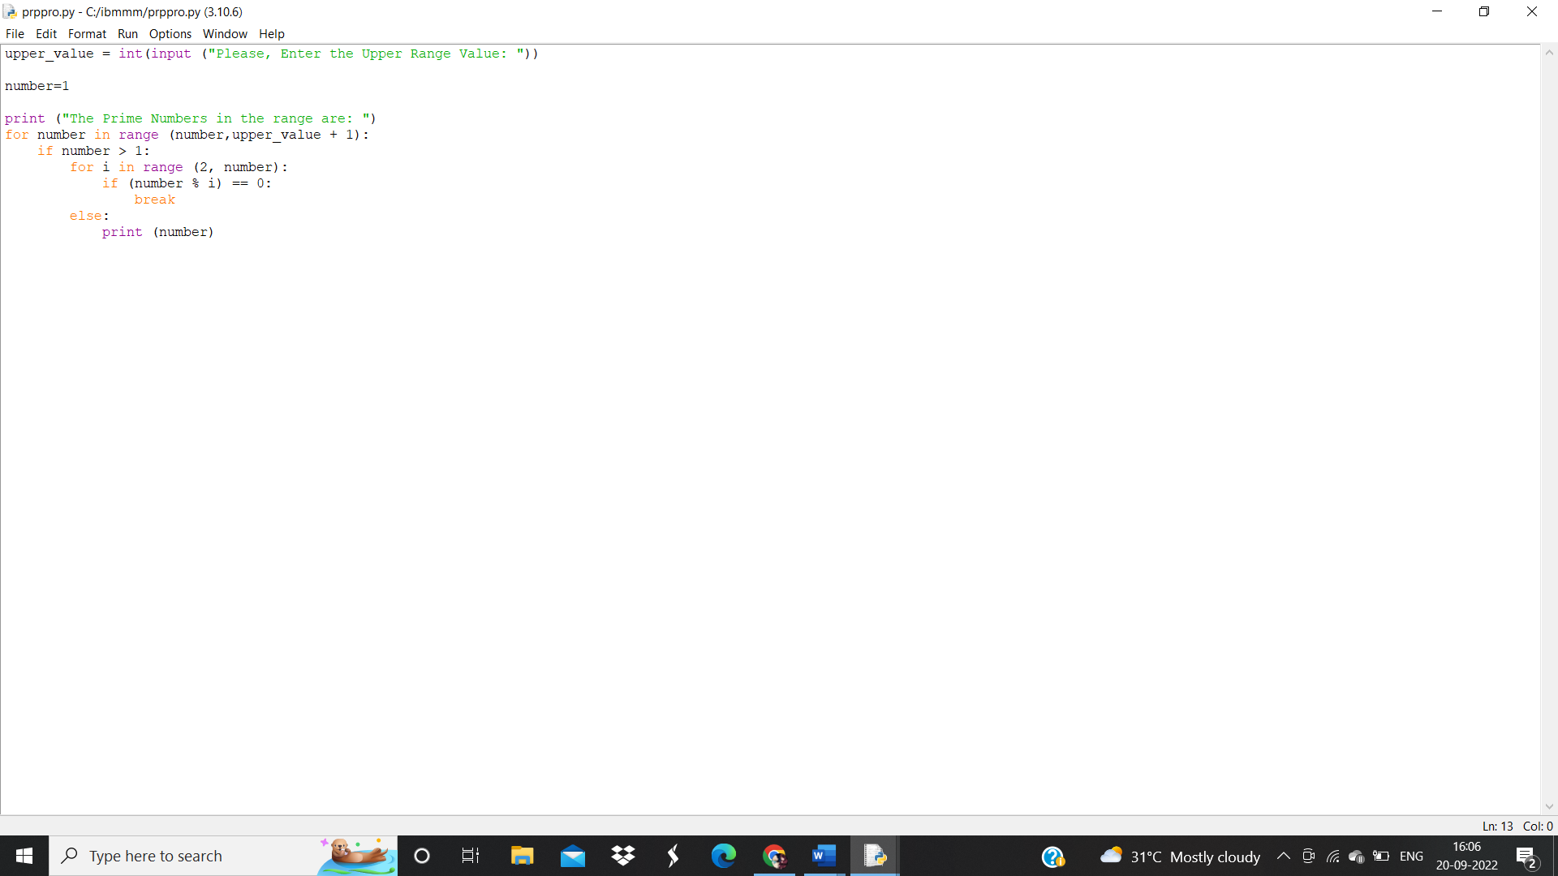

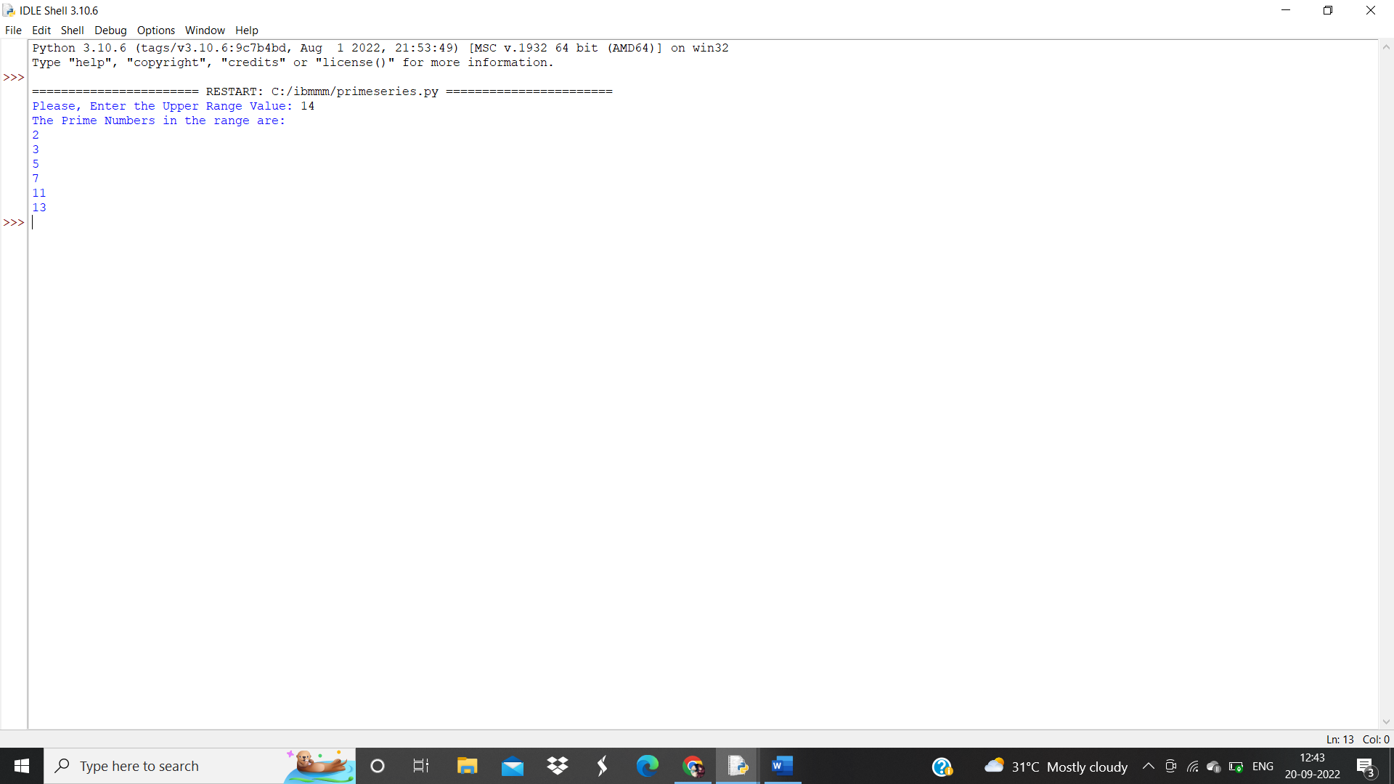

**Program 4:**

**Write a python program to generate Fibonacci series**

n_terms = int(input ("How many terms the user wants to print? "))

n_1 = 0

n_2 = 1

count = 0

if n_terms <= 0:

print ("Please enter a positive integer, the given number is not valid")

elif n_terms == 1:

print ("The Fibonacci sequence of the numbers up to", n_terms, ": ")

print(n_1)

else:

print ("The fibonacci sequence of the numbers is:")

while count < n_terms:

print(n_1)

nth = n_1 + n_2

n_1 = n_2

n_2 = nth

count += 1

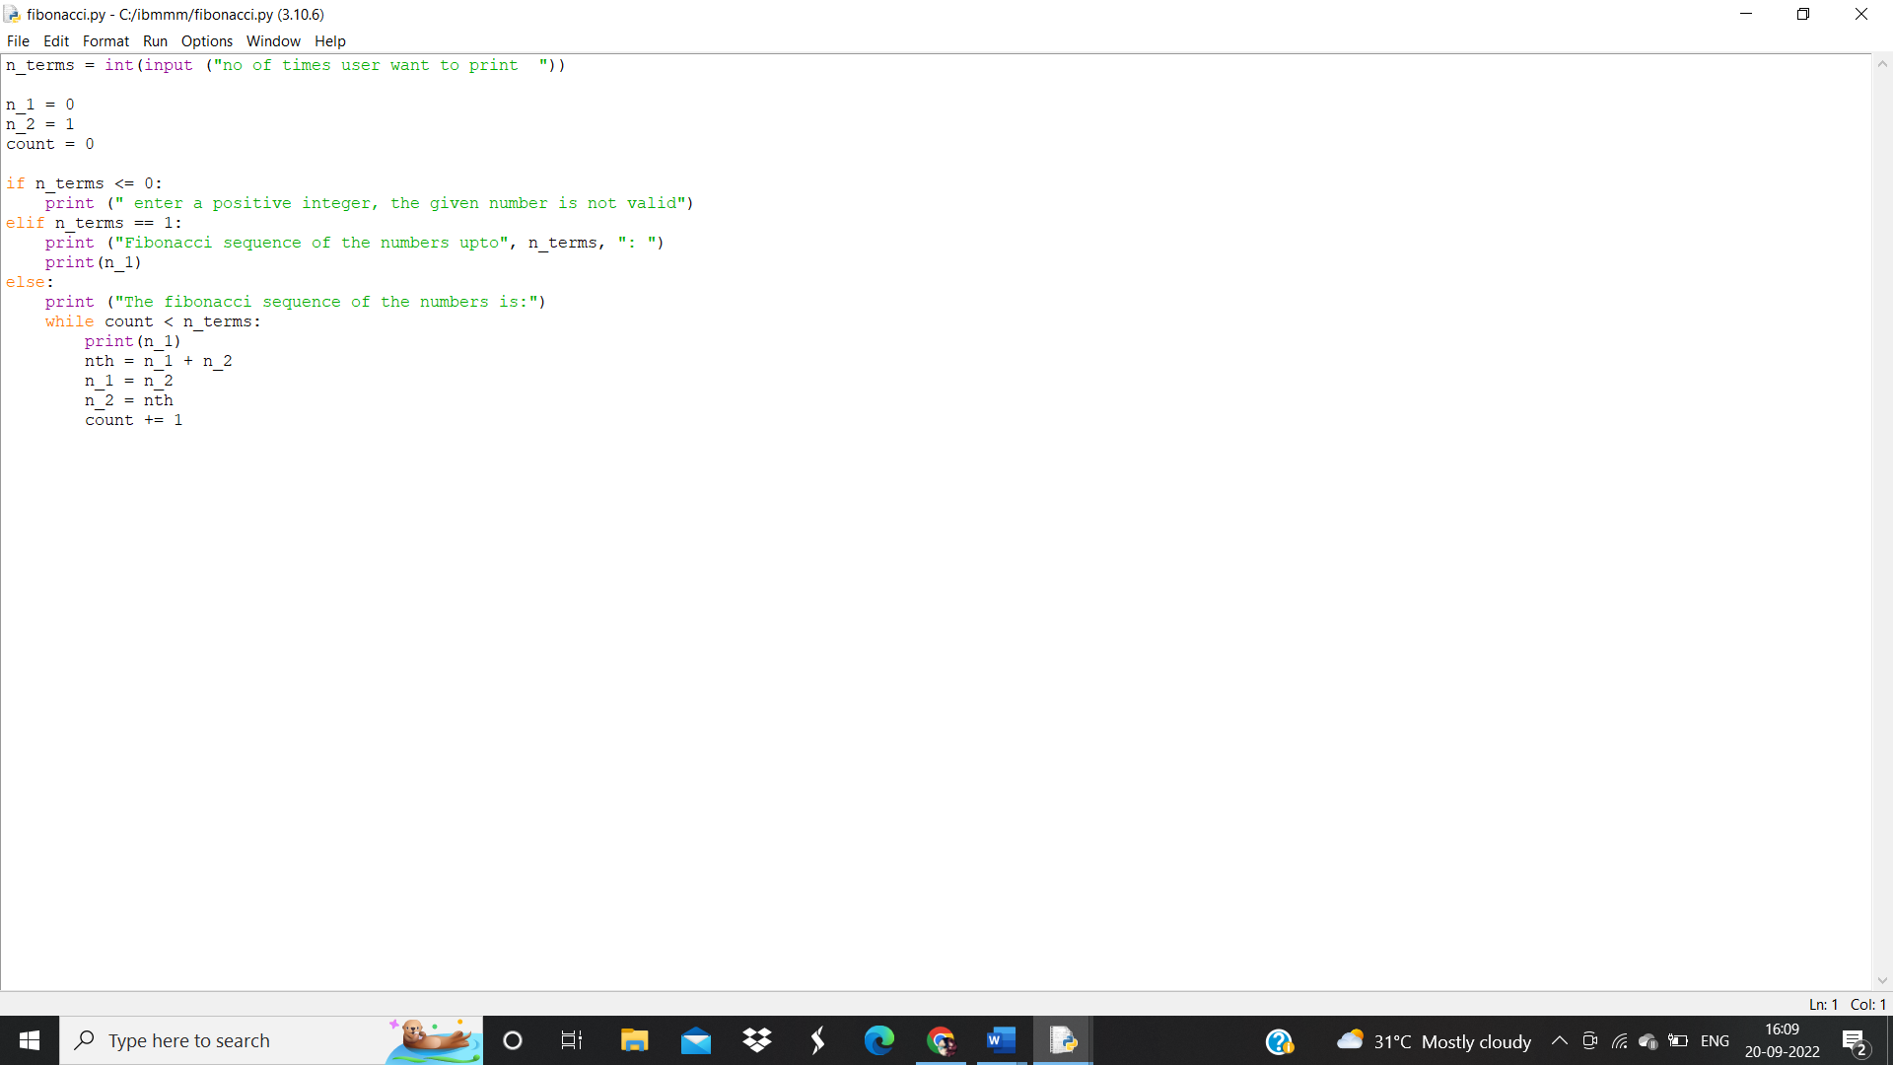

**Output:**

